THEORY QUESTIONS
1.
a)

In an experiment to demonstrate a property of light, three cardboards, A, B, and C with holes in their centres are arranged in a straight line between a lighted bulb and an observer as shown in the illustration below.
Study the illustration carefully and use it to answer the question that follow:
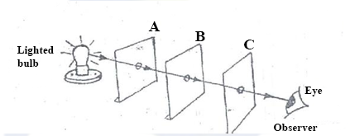
i)

What would the observer see from the position shown?
ii)

What would the observer see when cardboard B is slightly displaced from the line?
iii)

Explain the observation made in (a) (ii) above.
iv)

What would be observed when the cardboard B is brought back to its original position?
v)

What property of light is being demonstrated in this experiment?
vi)

Mention
α)

two natural occurrences that could be explained by the property of light demonstrated.
β)

one device that works on the property of light demonstrated.
b)

The diagrams below are illustrations of hazards symbols found in everyday life.
Study them carefully and use them to answer the questions that follow:
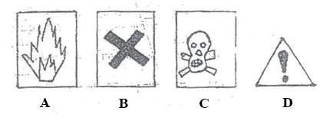
i)

What does each symbol A, B, C and D represent?
ii)

Name one substance each that is associated with each of the symbols A, B and C.
iii)

Name one place where the symbols D can be found.
iv)

State two advantages of hazard symbols.
c)

The diagrams below are illustrations of the different types of teeth in humans.
Study them carefully and use them to answer the questions that follow:
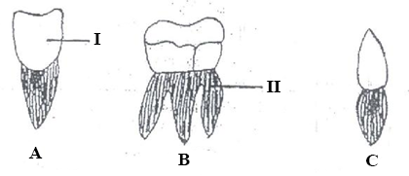
i)

Identify each type of teeth labelled A, B and C.
ii)

Describe the shape of each of the teeth labeled A, B and C.
iii)

State one function of each of the teeth labeled A, B and C.
iv)

Name the parts of the teeth labeled I and II.
d)

The diagrams below are illustrations of some farm tools.
Study them carefully and use them to answer the questions that follow:
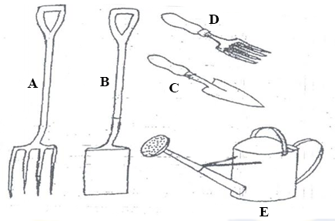
i)

Identify each of the following labeled A, B, C, D and E.
ii)

Mention one use of each of the tools labeled A, B, C, D and E.

2.
a)

i)

What are ruminants?
ii)

Give two examples of ruminants.
b)

i)

What is force?
ii)

State two effects of forces on the body.
c)

i)

Mention two ways in which the carbon cycle can be maintained.
ii)

State one environmental effect when the carbon cycle is disrupted.
d)

i)

Mention the three sub-atomic particles.
ii)

State the relative charge on each of the three sub-atomic particles mentioned in (d) (i) above.
iii)

Name the particle formed when an atom loses an electron.

3.
a)

i)

What is a mixture?
ii)

Explain why some mixtures are thoroughly stirred before they are used.
b)

i)

What is reflection of light?
ii)

State two characteristics of the images formed by plane mirrors.
c)

i)

What is a fertilizer?
ii)

Give one example of an inorganic fertilizer.
d)

i)

What is indiscriminate sex?
ii)

State two dangers of indiscriminate sex on humans.

4.
a)

i)

What is a simple machine?
ii)

Give two examples of a simple machine?
b)

i)

What is rusting?
ii)

State two effects of rusting.
c)

i)

What are food nutrients?
ii)

Classify the following food items as carbohydrate, fats and oil or protein:
Beans, palm fruits, meat, margarine, bread and maize.
d)

i)

State two effects of malnutrition in farm animals.
ii)

Mention one disease of farm animals caused by virus.

5.
a)

i)

What is soil erosion?
ii)

Name two methods of controlling soil erosion.
b)

Explain each of the following terms as used in ecology:
α)

Adaptation;
β)

Endangered species.
c)

i)

Give one example of hard water.
ii)

Explain why it is advisable to drink water which is hard.
d)

i)

What is magnetic field?
ii)

State two methods of making magnets.

6.
a)

i)

Define each of the following terms:
α)

solvent;
β)

solute.
ii)

Name one common solvent used in the home.
b)

Explain the following terms as used in animal production:
i)

ration;
ii)

dehorning.
c)

i)

What is an element?
ii)

Write down the symbol of each of the following chemical substances:
α)

Potassium;
β)

Sulphur.
d)

Explain each of the following terms:
i)

Mixed farming;
ii)

Mixed cropping.

